**Write a C program to Graph traversal using Depth First Search**

**INPUT:**

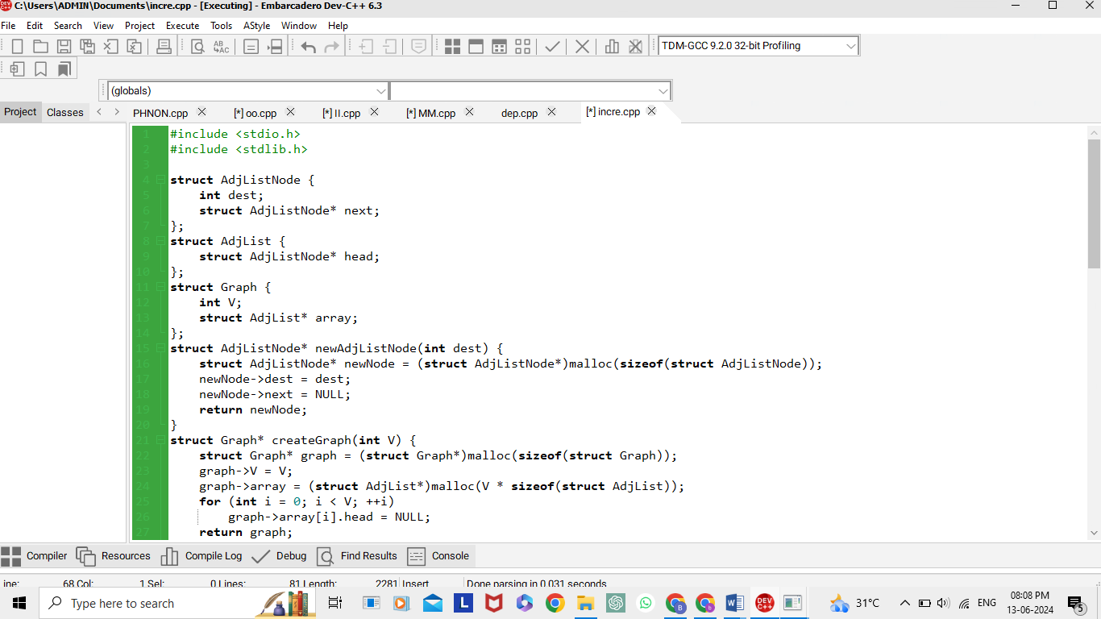

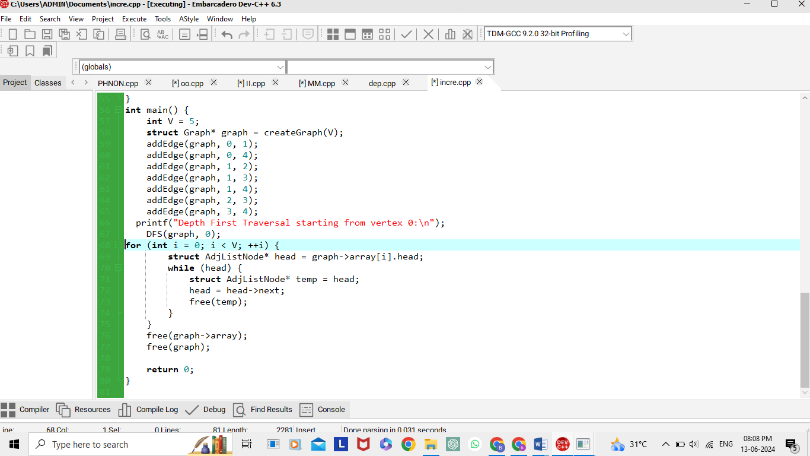

**OUTPUT:**

